
VELLORE INSTITUE OF TECHNOLOGY
BHOPAL
PROJECT REPORT
ON
DIGITAL LITREACY

PROJECT REPORT PREPARED BY-
Student Name Vihaan Agrawal
Branch B.tech-CSE Core
Registration number 25BCE10694

Introduction
The project is centered on raising awareness about digital literacy and online safety among college students. In this modern world, where digital growth is rapid, online platforms are being used for learning, communication, transactions, and socializing among students. However, this has also created different kinds of cyber threats for them, including phishing, fraud, and misuse of personal information.

The project will involve creating a digital literacy quiz, online safety practices, and understanding different cybercrime scenarios such as UPI fraud. Moreover, it will also focus on safe social media practices and online safety checklists for the students. The scenario will also shed light on how lack of awareness and improper digital literacy can cause serious consequences for them.

Task-1
For my project, I designed an infographic about the topic of "digital literacy" with the help of Canva. The design displays a clear and interesting description of what "digital literacy" is and why it is important for students today. The design includes the key topics that a digitally literate person needs to understand, such as "using digital tools," "analysing information," "safe internet practices," "managing projects," and "building a professional online presence." Additionally, the design includes the importance of "digital fluency," such as "boosting productivity," "enhancing learning," and "showcasing skills for future careers." Finally, the design includes "some useful tips" such as "spotting fake news" and "using two-factor authentication.

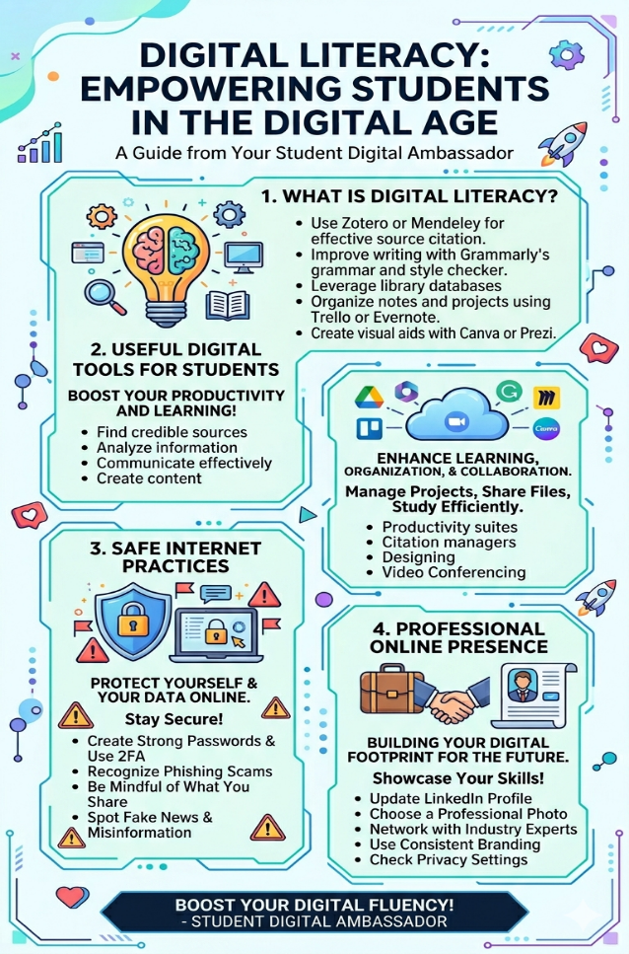
Something interesting that I learned while making my project was that "digital literacy" includes many different professional and safety skills that a person needs to have, and it is not just about "knowing how to use basic software." However, it was a bit hard for me to organize all the information across four distinct topics in a neat manner without making the design look too crowded."

Task-2
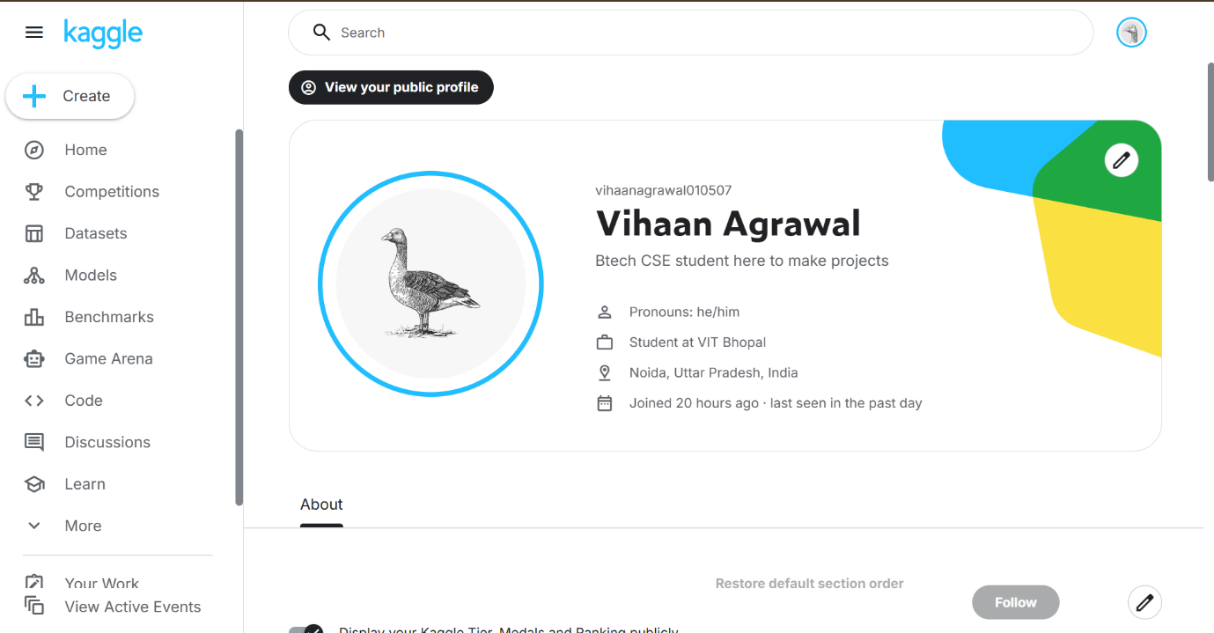
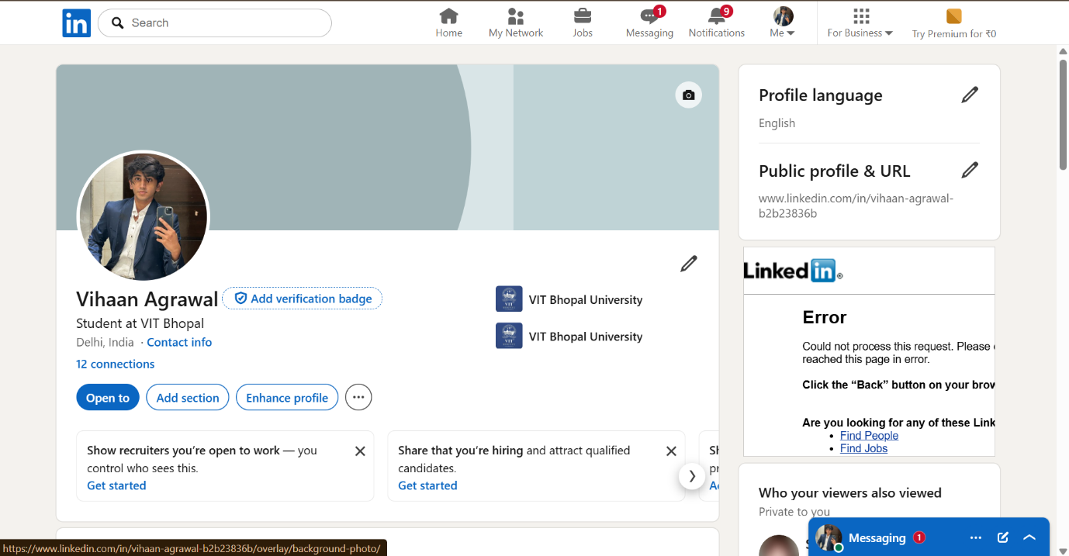
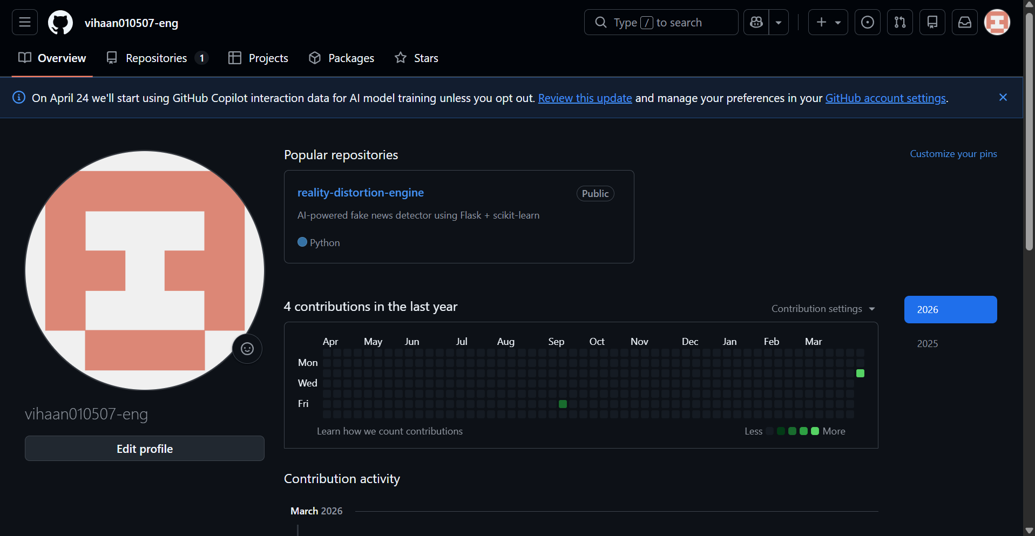
For my academic and professional growth, I have decided to focus on three main platforms: GitHub, Kaggle, and LinkedIn. Each of these plays a different role in helping me grow in the field of Artificial Intelligence and Machine Learning.
GitHub is where I can actually show what I’ve built. I plan to upload my projects like web applications, AI models, and other coding work so that others can see my progress. Over the next few years, I want to keep improving by contributing to projects, collaborating with others, and working on real-world ideas.
Kaggle is a platform where I can practice and challenge myself. By working on different datasets and participating in competitions, I can improve my machine learning and problem-solving skills. I hope that with consistent effort, I’ll be able to earn medals and get recognized in the Kaggle community.
LinkedIn will help me connect with people and explore opportunities. I want to share what I learn, post about my achievements, and build a strong professional network. Over time, this can help me find internships and job opportunities.
Overall, these platforms will support me in building my skills and growing both academically and professionally.

Task-3
For this project, I used Google Forms to create a quiz called “Digital Literacy Awareness Quiz.” It is a simple and effective tool for making surveys, quizzes, and questionnaires in an organized way. Using Google Forms, I was able to design a quiz with five different types of questions, such as multiple choice and short answer, to test basic understanding of digital literacy topics like online safety, password security, and responsible use of online platforms.
While creating the form, I used skills like framing clear questions, choosing the right type of questions, and using quiz features to make it more interactive and easy to use. This process helped me understand how to present information in a structured and user-friendly way.
Google Forms can be very useful for me academically, especially for creating surveys, collecting responses, and working on projects. In the future, I can use it for research work, feedback collection, and other academic tasks. It also helps me become more familiar with digital tools, which is important for my growth in the field of Artificial Intelligence and technology.

Task-4
E-mail-1
Subject- Request for Extension on Assignment Submission
Dear Sir/Madam,
I hope you are doing well.
I am writing to request a short extension for the submission of the assignment provided yesterday in the classroom, which is currently due on 30th March 12:00AM. Due to an emergency in my family I will have to head back home, I have been unable to complete the assignment to the best of my ability within the given time.
I sincerely value the quality of my work and would like to request an extension until 2nd of March so that I can submit a more complete and well-prepared assignment.
I apologize for any inconvenience this may cause and assure you that I am making every effort to complete the work as soon as possible. I would be very grateful for your consideration.
Thank you for your time and understanding.
Yours sincerely,
Vihaan Agrawal
Btech CSE (core) 25BCE10694

E-mail-2
Subject- Application for Summer Internship Opportunity

Dear Sir/Madam,
I hope this message finds you in the best of health and spirits. I am writing this letter to express my interest in a summer internship program with your esteemed organization.
I am a student currently pursuing a degree in Artificial Intelligence and Machine Learning, and I wish to apply my knowledge in a real-time environment. I have hands-on experience with technologies like Python, web development tools, and machine learning basics. I am highly motivated to learn, contribute, and grow with hands-on experience.
I would be highly grateful if you could consider me for an internship position in your esteemed organization. Please let me know whether there are any available positions in your organization or whether you require any additional information from me, like my resume or portfolio.
Thank you for your time and consideration.

Sincerely,
Vihaan Agrawal

PROJECT REPORT FOR THE CHECKLIST
Poor digital communication can often cause confusion, especially in academic or professional environments. For instance, in a group project, if one student says, “I’ll take care of the report,” it may sound clear at first, but it actually leaves room for different interpretations. Other group members might assume everything is under control, but when the submission deadline arrives, they may find the report incomplete. Because of this misunderstanding, the whole group ends up getting lower grades.
This problem could have been avoided with clearer communication. The student could have specified exactly which part of the report they would handle and shared regular updates with the team. When communication is clear, everyone knows their responsibilities and can track the progress of the work.
Overall, effective digital communication means being specific, staying in touch with updates, and ensuring that everyone involved has a clear understanding of their roles.

Task-5
While researching this topic, I realized how even small mistakes online can lead to serious cybercrimes. Simple actions like clicking on an unknown link or entering a UPI PIN without proper verification can result in instant financial loss. What stood out to me the most was how cleverly scammers copy the identity of banks, companies, or even known contacts, which makes it very difficult to recognize them as fraud.
Because of this, I have decided to become more careful in my online activities. I will make it a habit to double-check every link, message, or payment request before taking any action. I also plan to avoid making quick decisions, especially in situations that create urgency or pressure.
Adopting these habits will help me stay more aware and protect myself from potential online threats in the future.

Conclusion:
This project helped me better understand the importance of digital literacy and responsible online behavior in today’s world. I realized how even small actions, like clicking on unknown links or sharing personal information, can lead to serious issues such as cyber fraud. Working on the quiz, checklist, and case study also gave me practical knowledge about online safety and effective digital communication. It wasn’t just theoretical—I got to apply what I learned in real situations.
Overall, this project has made me more aware and careful while using digital platforms. It has also increased my confidence in using online tools in a safe and responsible way.

References:
- Google Forms (for quiz creation)
- National Cyber Crime Portal (https://cybercrime.gov.in)
- General awareness articles on cyber safety and UPI fraud

